Assignment - 6

Title:- Implement of Expert system Help Desk Management System Program :-

Help Desk Management System

# Define a dictionary of common problems and their solutions problem_dict = {

"Printer not working": "Check that it's turned on and connected to the network",

"Can't log in": "Make sure you're using the correct username and password",

"Software not installing": "Check that your computer meets the system requirements",

"Internet connection not working": "Restart your modem or router", "Email not sending": "Check that you're using the correct email server

settings"

}

# Define a function to handle user requests def handle_request(user_input):

if user_input.lower() == "exit": return "Goodbye!"

elif user_input in problem_dict: return problem_dict[user_input]

else:

return "I'm sorry, I don't know how to help with that problem."

# Main loop to prompt user for input while True:

user_input = input("What's the problem? Type 'exit' to quit. ") response = handle_request(user_input)

print(response)

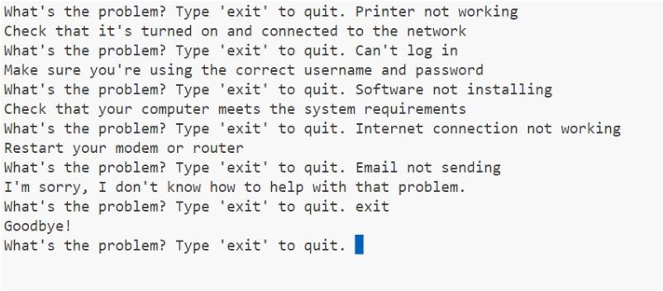Output:-